# CS 255 System Design Document

## UML Diagrams

### UML Use Case Diagram

*Based* on Liam, Ian (personal communication, January 22, 2021)*, the system will provide the following function:*

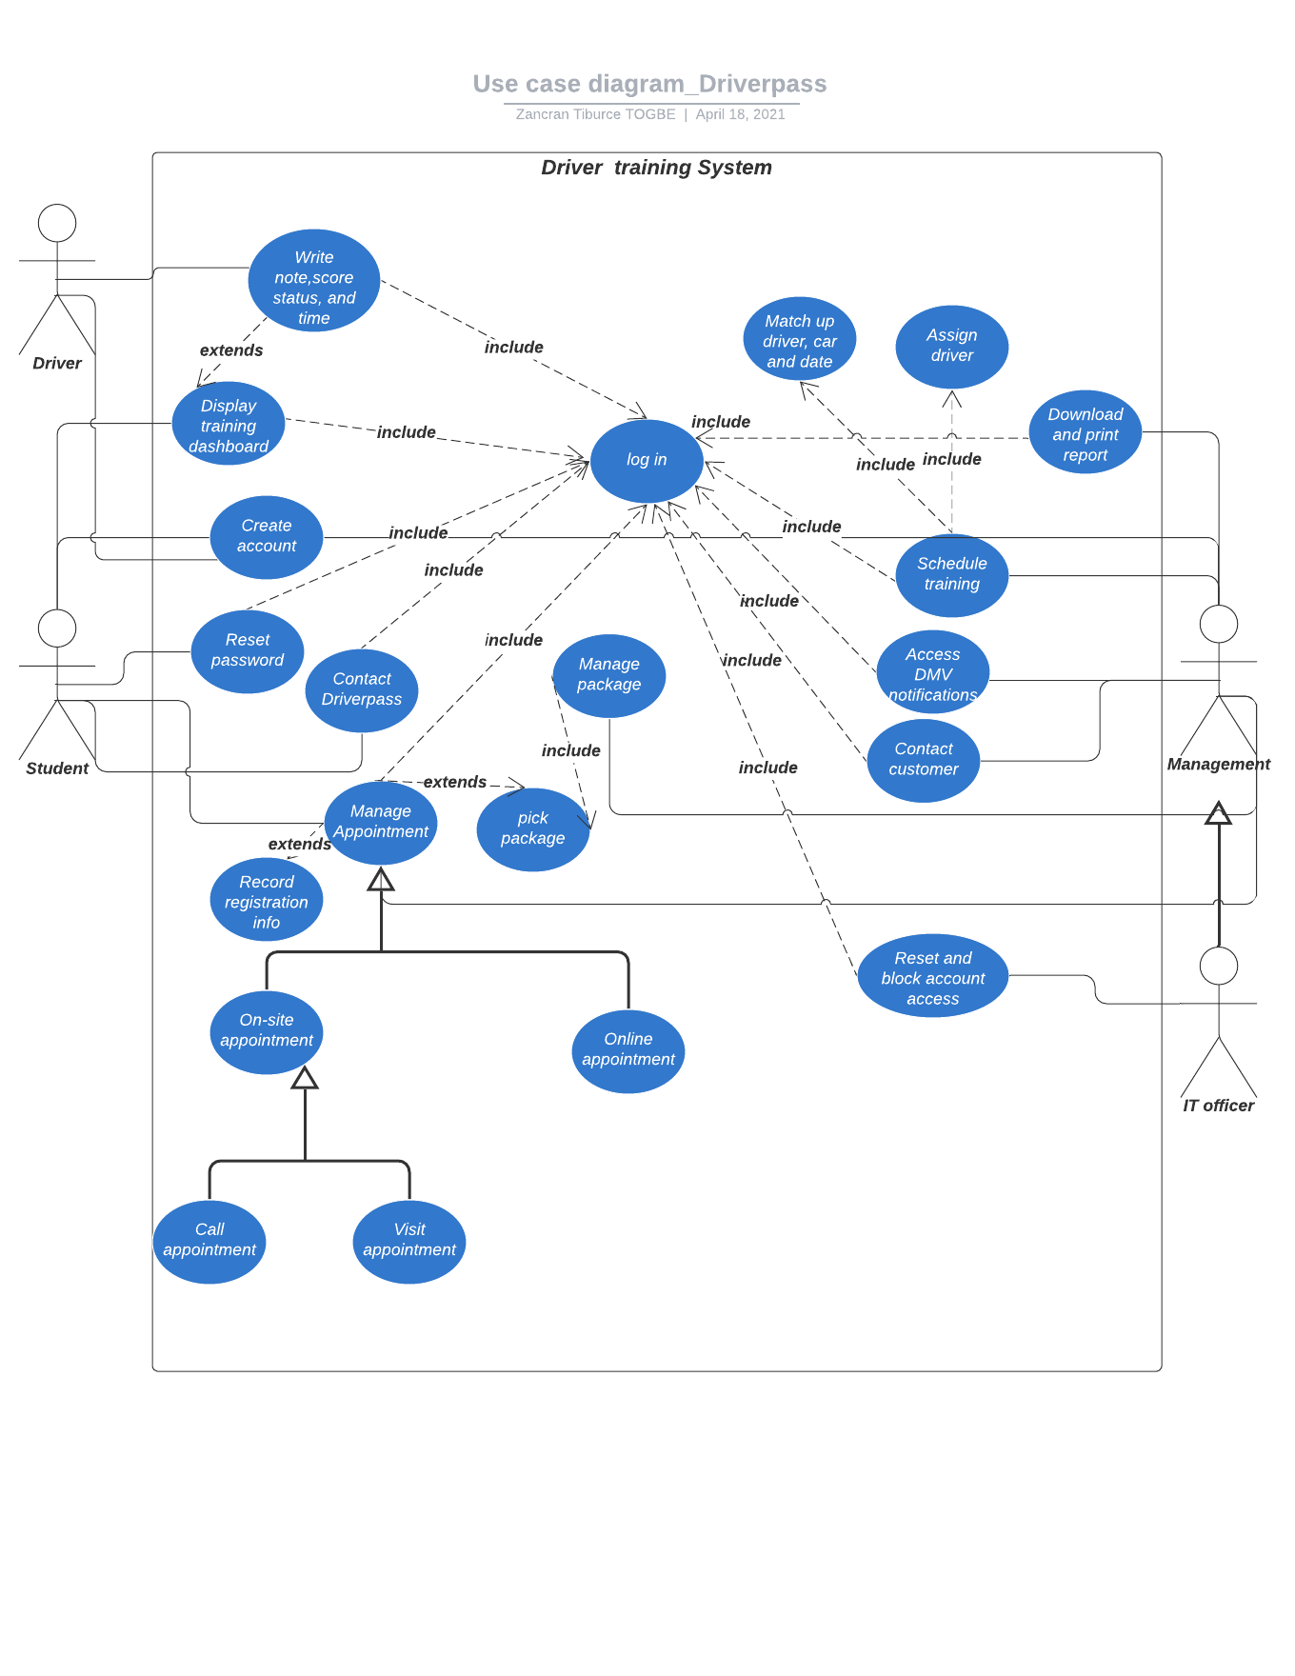

### UML Activity Diagrams

*Based* on Liam, Ian (personal communication, January 22, 2021)*, we present two activity diagrams based on the use cases to create an account and reset a password.*

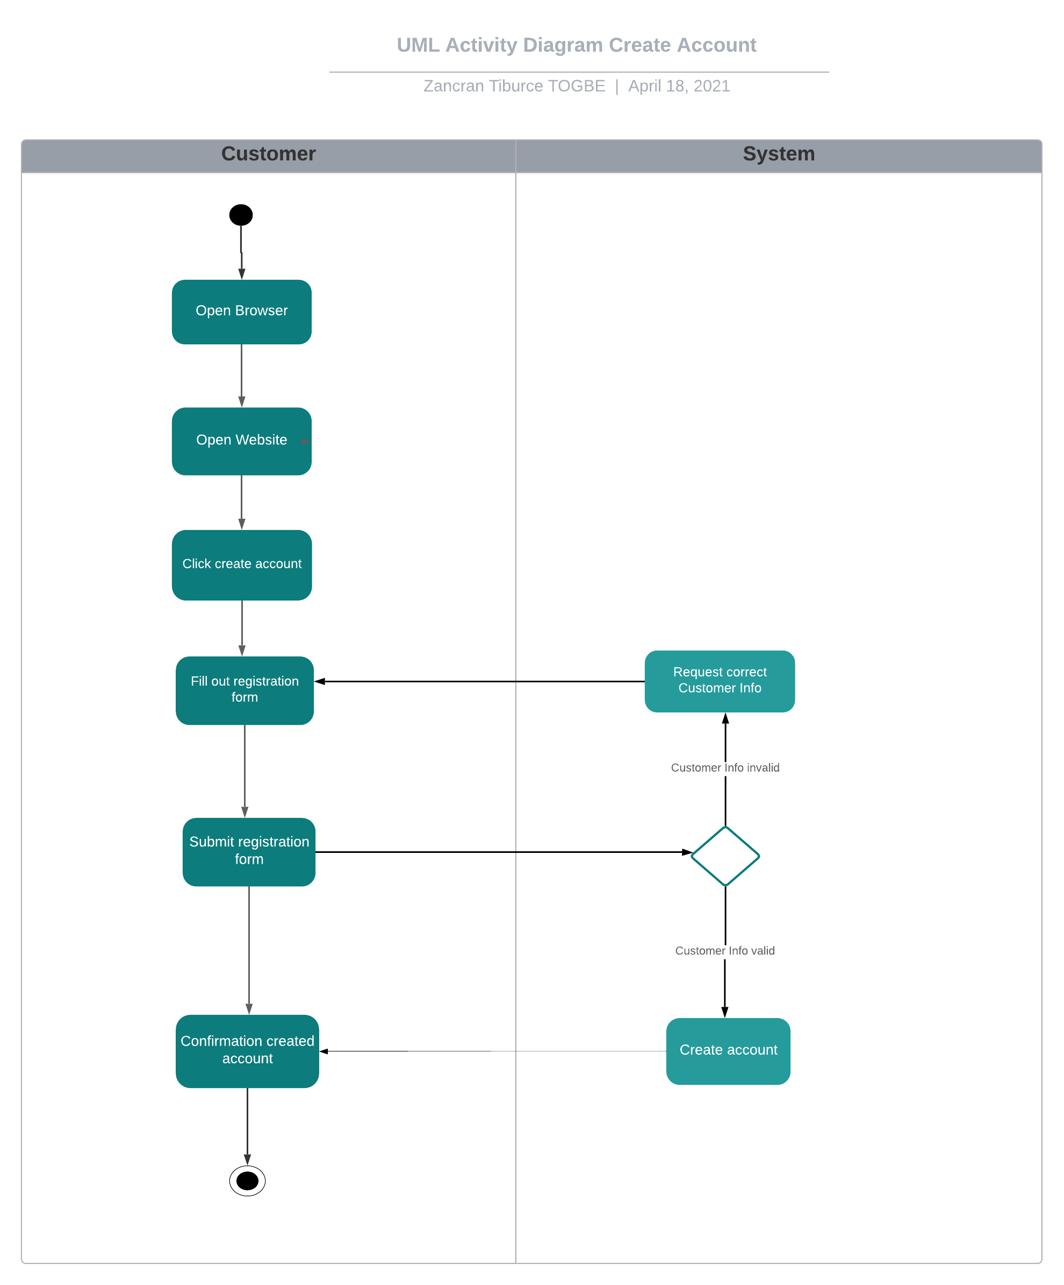

### 

### UML Sequence Diagram

*Based* on Liam, Ian (personal communication, January 22, 2021)*, the sequence diagram reset a password draw from the use case reset a password.*

~~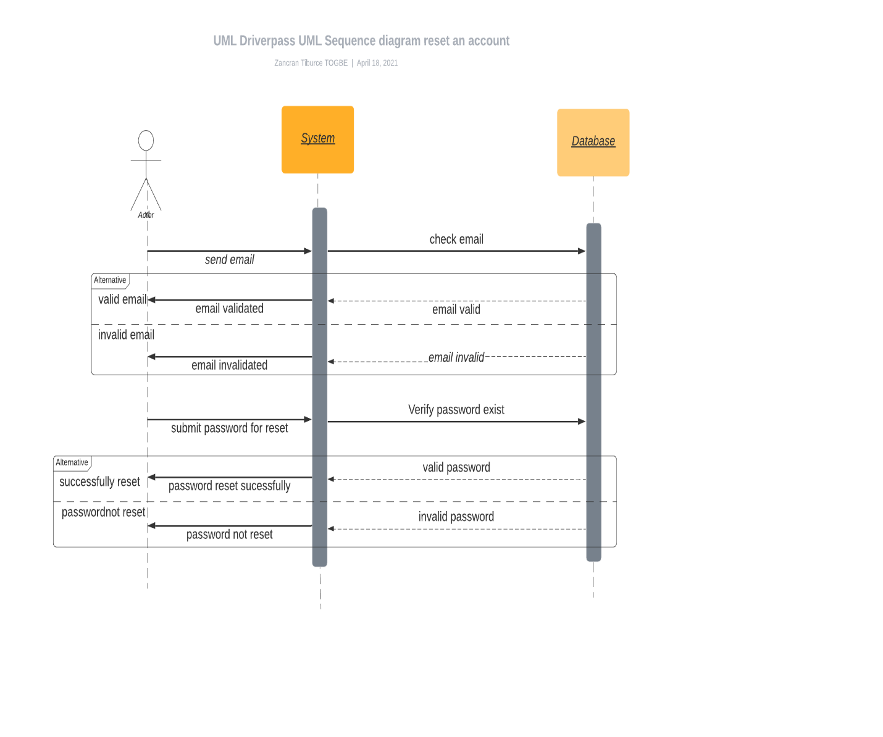~~

### UML Class Diagram

*Based* on Liam, Ian (personal communication, January 22, 2021)*, the system will provide the following component and interaction:*

~~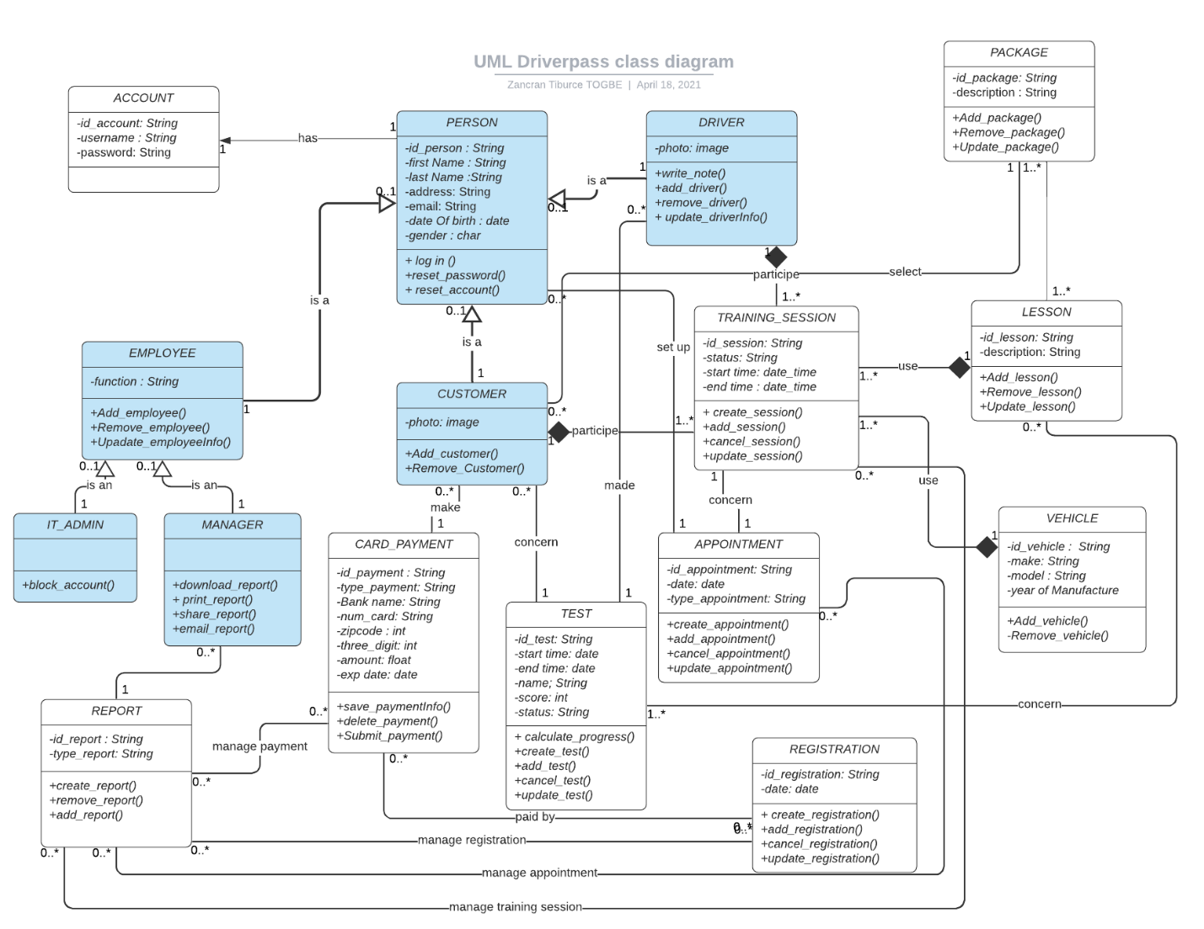~~

## Technical Requirements

*Based* on Liam, Ian (personal communication, January 22, 2021)*, the system will run on a cloud architecture*

* *Hardware*
* *Cloud choice: Amazon EC2 platform ( Mac and M5 instances)*
* *Software*
* *User Interface technology: Native UI( iOS, Android, Windows, macOS) and HTML5*
* *Cross compiled approach tool: Xamarin*
* *Browsers: Microsoft Edge, Google Chrome, Firefox, Opera, Safari*
* *Cross-platform framework abstraction: Javascript API, C#libraries, Android API, iOS API, Windows Phone API*
* *Database management system: MySQL*